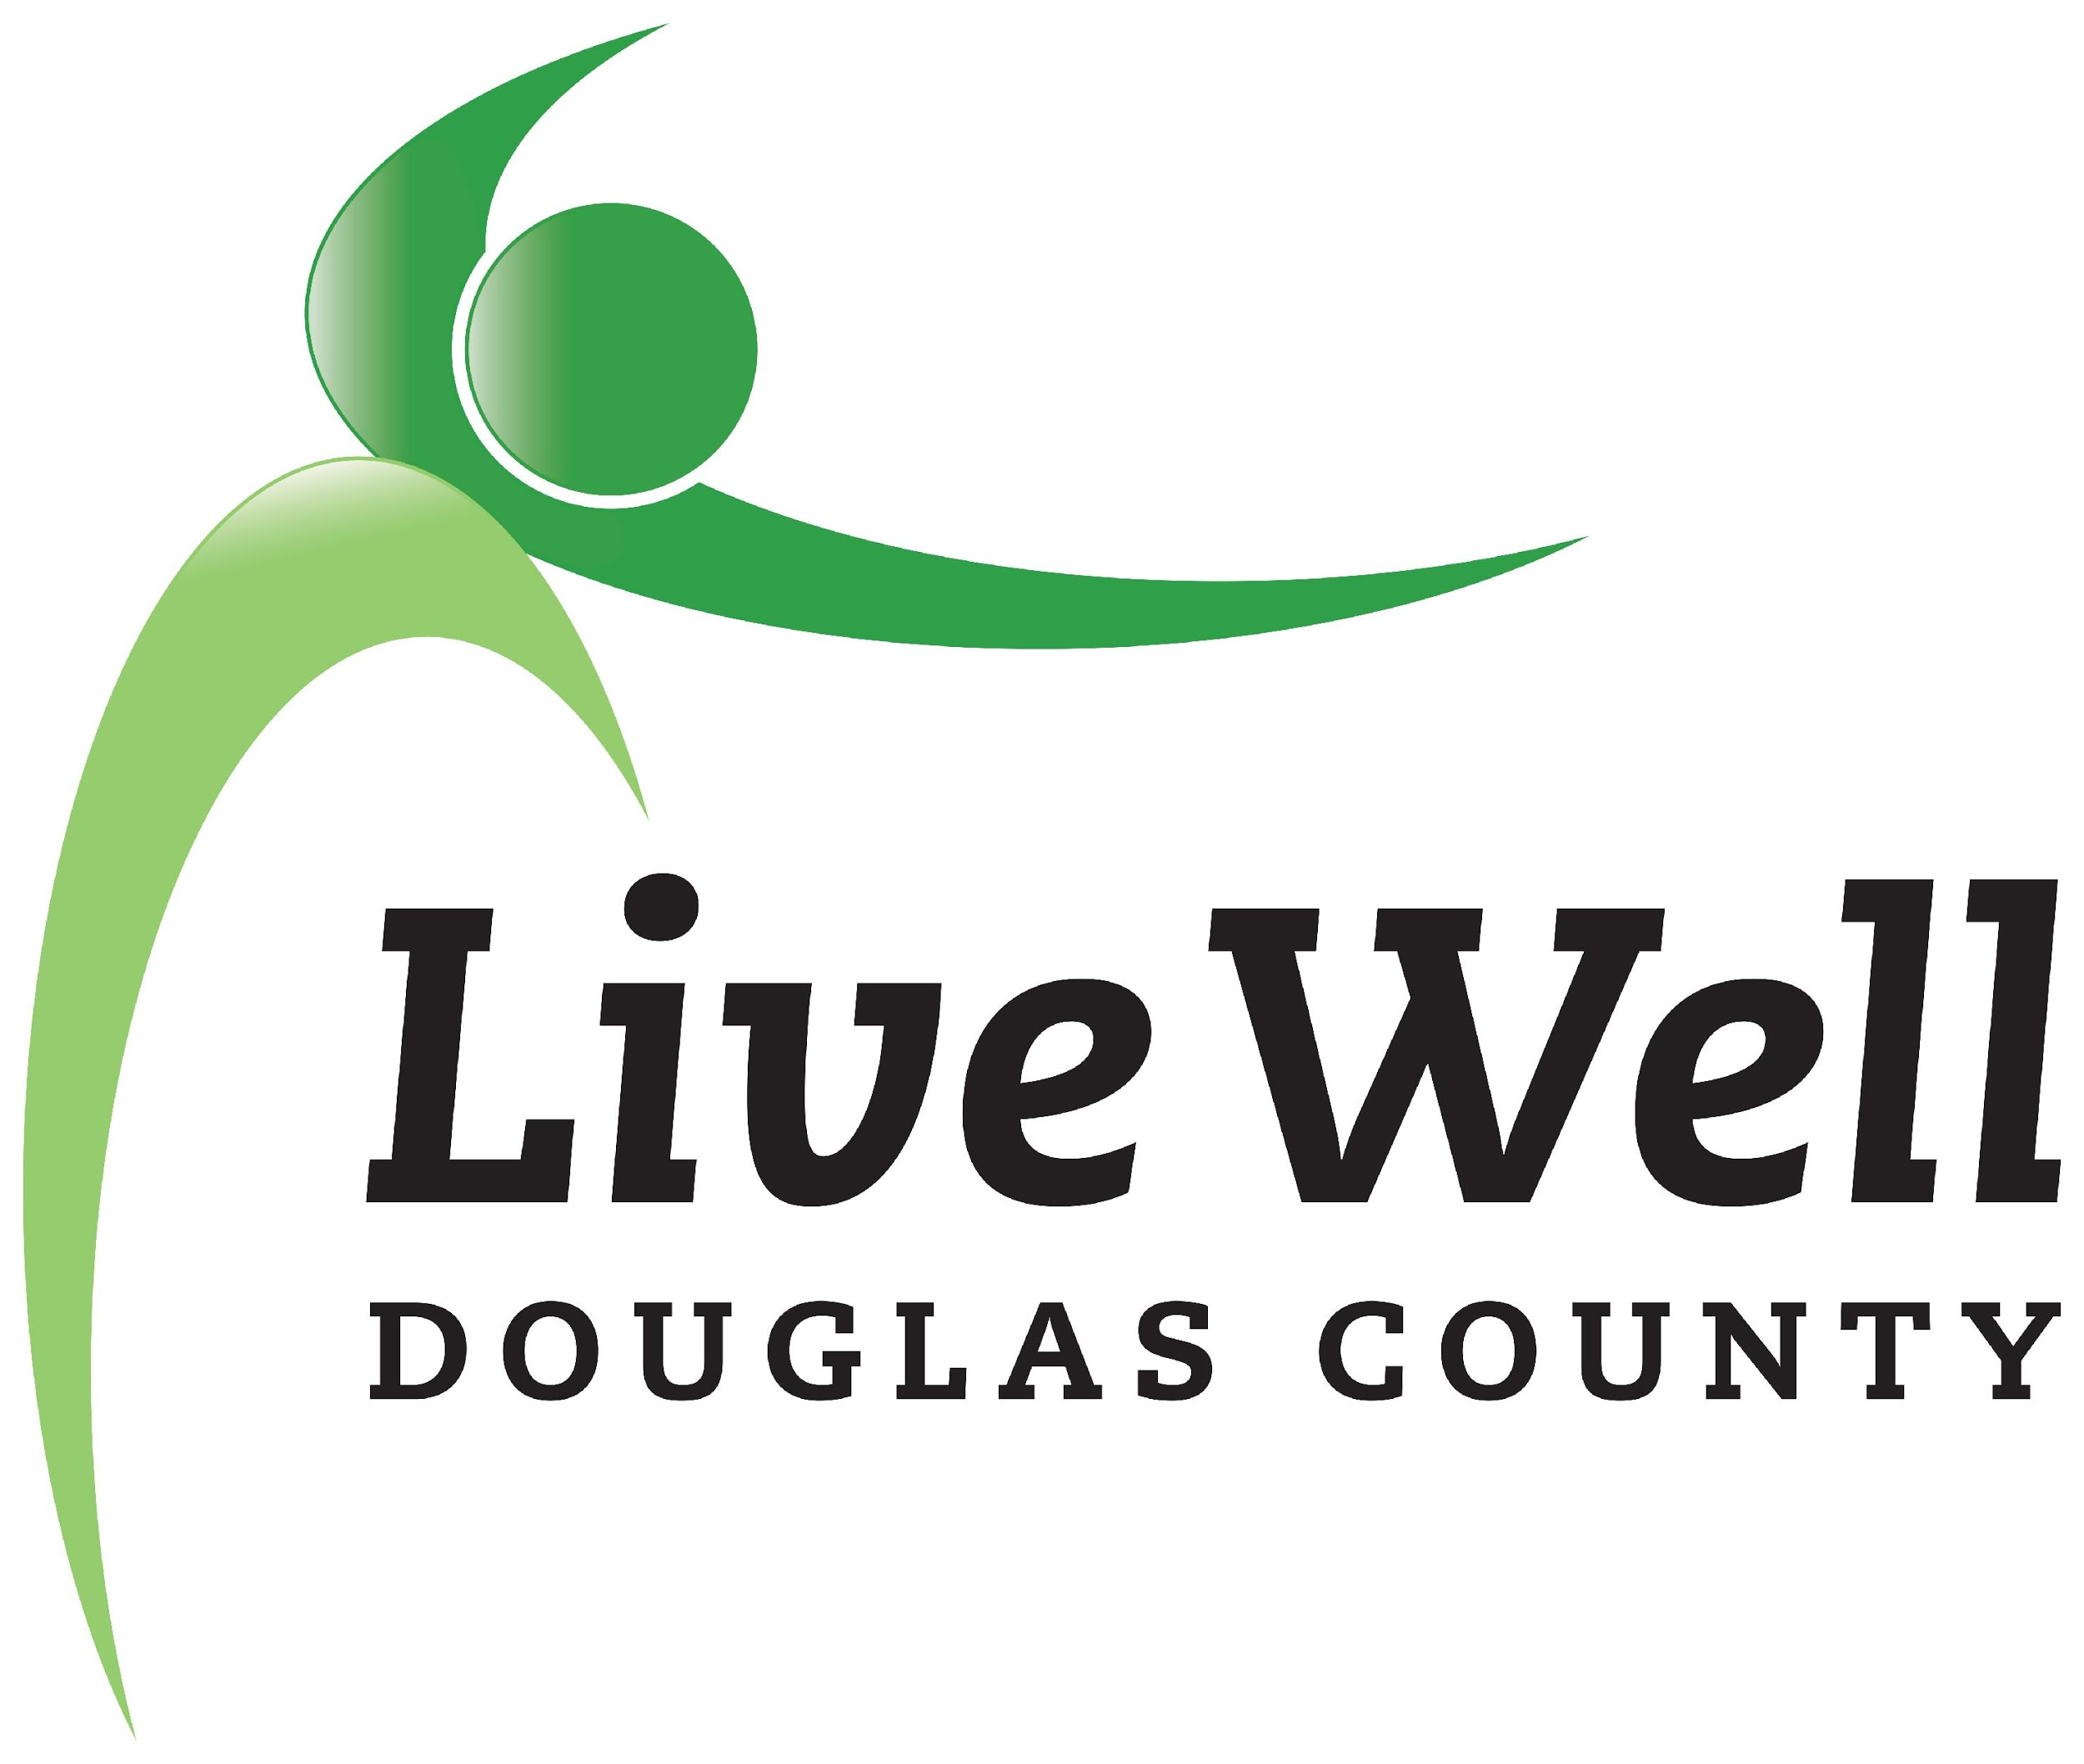
Leadership Team
Meeting Minutes

August 13, 2021 11:00am - 12:30pm
Online via Zoom (https://ksu.zoom.us/j/98862801428)

Mission: leading a movement to build communities that support the health and well-being of all.
Vision: Communities where we all thrive.

Item | Notes | Accomplishments/Action Steps:
Call to Order/Introductions | Attendees:  Chris asked each team member to share a “silver lining” they discovered during/through the pandemic.  Mentions: more time with family, more intentional choices around how to spend time, the discovery of new ways of working, learning, and teaching, learning the power of rest, the value of companionship of pets, and discovery of time to work on projects that wouldn’t have gotten done in “normal” times.
Goal Setting | - Chris led a discussion about creating goal statements for each work group:  - Identify broad goals (supporting local efforts & partners)  - Identify how progress will be tracked  - Ideally format the goals as SMART goals the best you can  - Resources for goals include community wide plans including the Community Health Plan and many others (https://dashboards.mysidewalk.com/healthiertogether)  - Deadline: 9/30/21 | Accomplishments:
Action Steps:
- Each work group is to submit a goal statement by 9/30/21.
Communications | List Serves – Originally developed by Marlin. Marty will assume that role.  - Groups that have a list include: HFFA, WorkWell, Healthy Kids, & Leadership. Marty will work with those groups who currently do not have a list.  - Work Group documentation will be posted in SharePoint  - The format/template for meeting minutes is encouraged.  - Website: LiveWell’s website is out dated and will be refreshed (free of charge) by Civic Plus. | Accomplishments:
Action Steps:
- Marty will reach out to work groups without a list serve to get a list of attendees.
- Work groups will email meeting minutes to Marty to post on the SharePoint site.
- Work groups should also update the Community CheckBox with work group accomplishments as soon as possible. Work group leaders should contact Marty if you they want assistance documenting accomplishments in the data base.
Pathways Mini-onsite Visit | - Tuesday, August 24 from 2:30-4:00 pm at the K-State Research and Extension office  - Workgroup leads and co-chairs are encouraged to attend to meet the technical advisors for the grant, ask questions, and/or share the impact and challenges of working on the grant. | Accomplishments:
 |  | Action Steps: Marty will identify a hybrid approach for the meeting
Workgroup Reports and Announcements | Given time constraints work group reports were not given at this time. | Accomplishments:
 |  | Action Steps: Work groups were invited to provide any updates or announcements to Marty who can distribute to the full Leadership Team.
Adjournment | The meeting was adjourned at 12:02pm.

